
Web Application Reconnaissance & Initial Security Assessment Report
Week 1 Cybersecurity Internship Task – OWASP Juice Shop

Executive Summary
This report summarizes the Week 1 reconnaissance and initial security assessment of the OWASP Juice Shop application conducted as part of a cybersecurity internship task. The assessment aimed to understand the application structure and identify potential security weaknesses through logical and observational testing.
Burp Suite, Browser Developer Tools, and Nmap were used to perform both network-level and application-level analysis. Testing revealed several security issues, including exposed application paths, weak authentication and session handling, improper input validation, broken access controls, and sensitive data exposure.
These findings show how multiple vulnerabilities can be combined to achieve unauthorized access, emphasizing the need for strong server-side validation, secure session management, and proper authorization controls.

Methdology
The assessment was conducted on the OWASP Juice Shop application as part of the Week 1 cybersecurity internship task. A structured approach was followed to understand the application and identify security weaknesses. Nmap was used for basic network-level reconnaissance to identify open ports and running services. Browser Developer Tools were used to analyze HTTP requests and responses, inspect JavaScript files, identify API endpoints, and observe client-side behavior.
Burp Suite was used to intercept and analyze application traffic, particularly during authentication and session handling. Requests were modified in a controlled manner to test input validation and access control mechanisms. All testing was performed manually to ensure logical understanding of each identified issue. Evidence was documented through screenshots along with clear explanations of each step.
Finding and Analysis
The assessment identified multiple security weaknesses within the application. Reconnaissance revealed several exposed endpoints, APIs, and client-side files, increasing the overall attack surface. The robots.txt file disclosed disallowed paths that could assist attackers in locating sensitive application areas.
Authentication testing showed weaknesses in login handling, including informative error messages and acceptance of weak passwords. Session analysis indicated improper session handling, which could allow session reuse or fixation. Input validation testing revealed that user input was not properly sanitized, making the application vulnerable to injection-based attacks such as SQL Injection and Cross-Site Scripting (XSS).
Access control testing identified broken authorization checks, where restricted resources could be accessed through direct URL access or request manipulation. Additionally, sensitive internal information was exposed through JavaScript files and API responses. These findings demonstrate that multiple vulnerabilities could be chained together to achieve unauthorized access or privilege escalation.

Task 1(part1)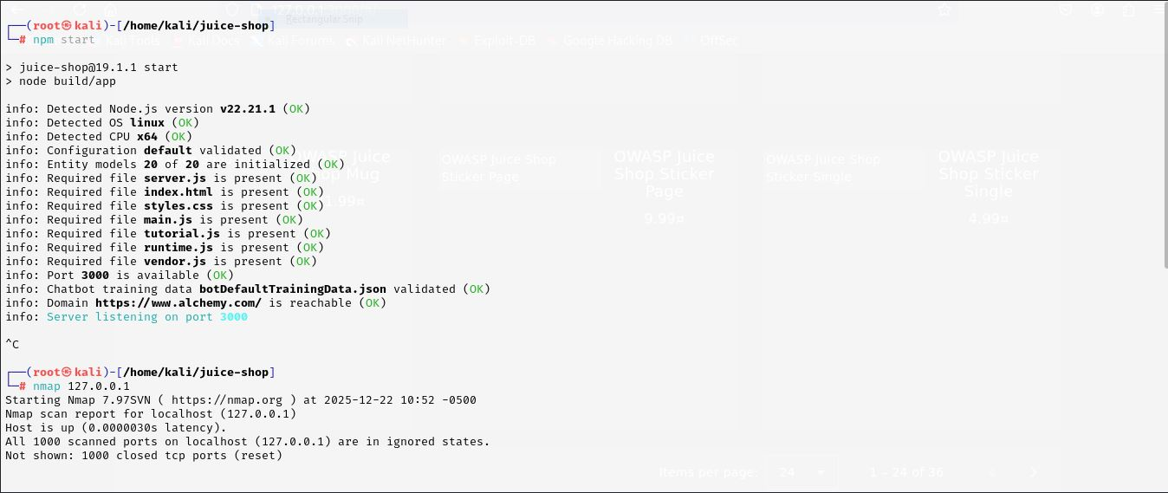
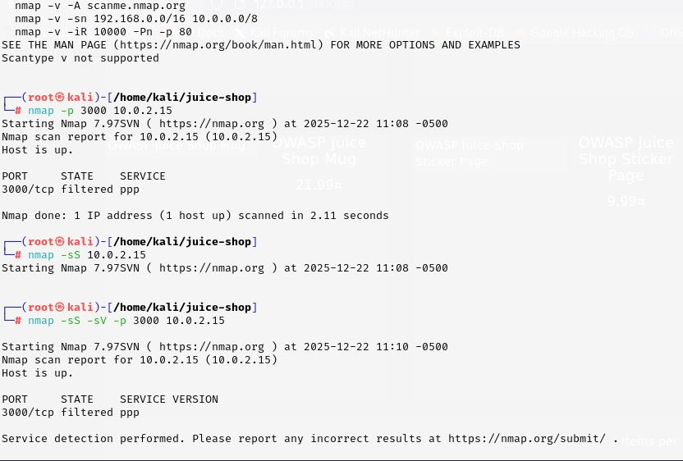
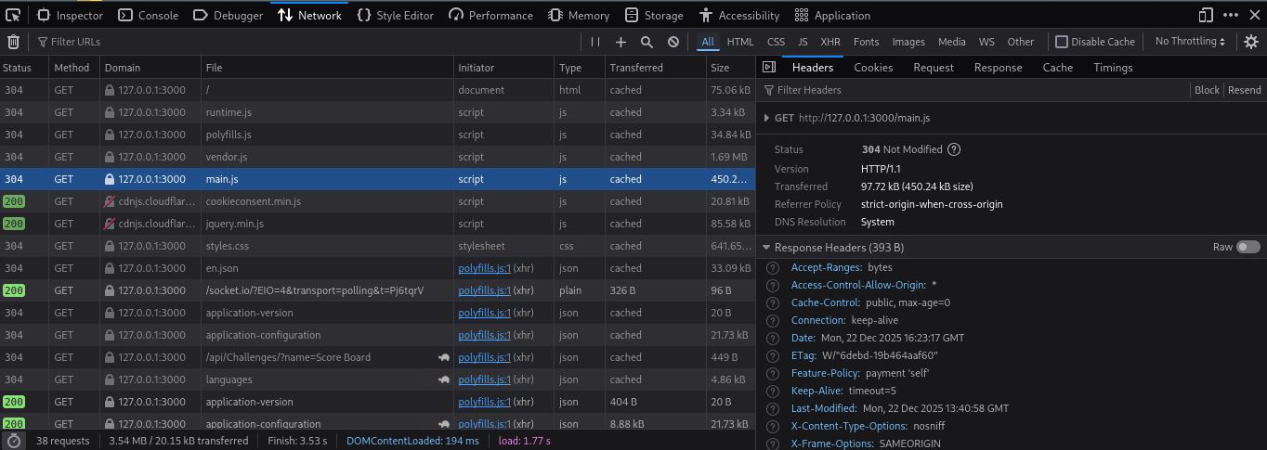
Task 1 (part 2)
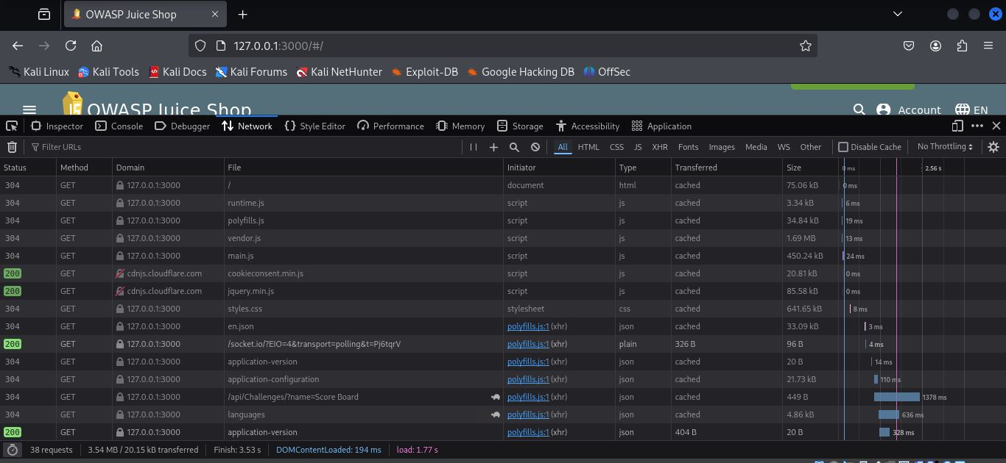
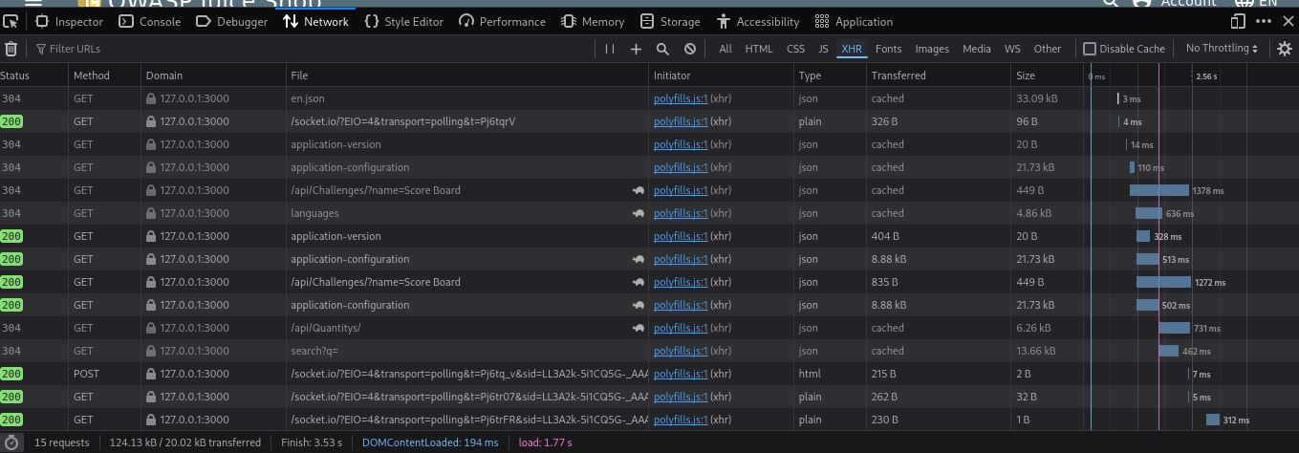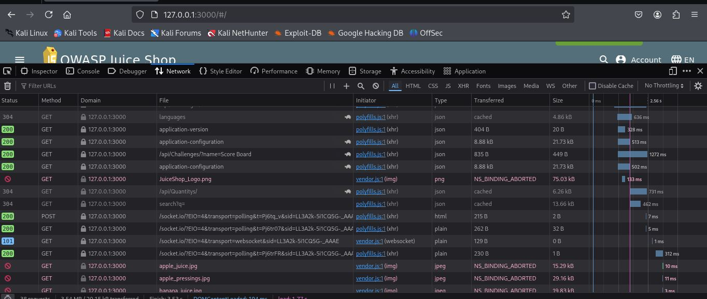

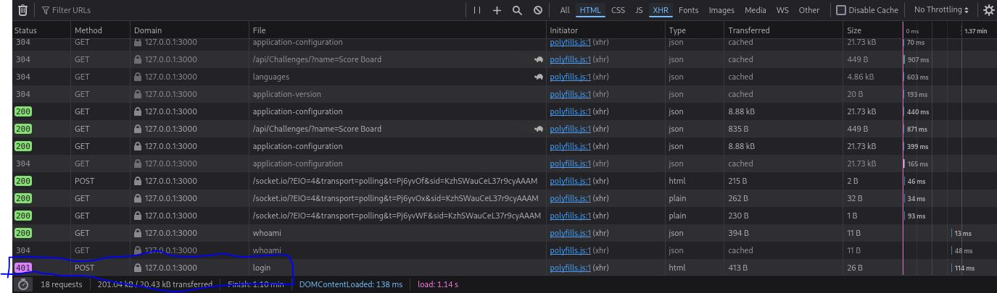

Evidence (Part 2: Application-Level Reconnaissance)
During application-level reconnaissance using browser developer tools, the following endpoints and files were identified from the Network and Sources tabs:
Identified Endpoints:
- /login
- /whoami
Identified Files:
- application.config
- main.js
- CSS files (used for application styling)
Screenshots of the network traffic showing HTTP requests and responses, along with JavaScript and file analysis, have been captured and attached as evidence

Task 1(part 3)
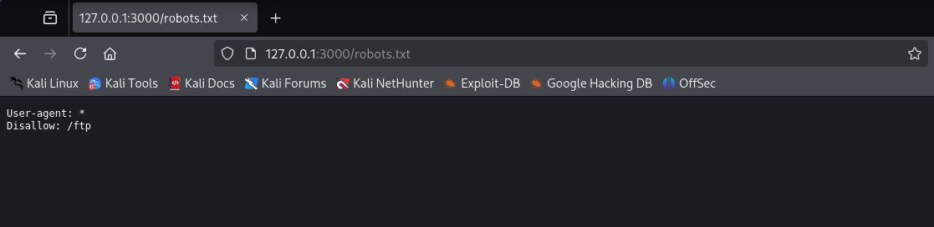
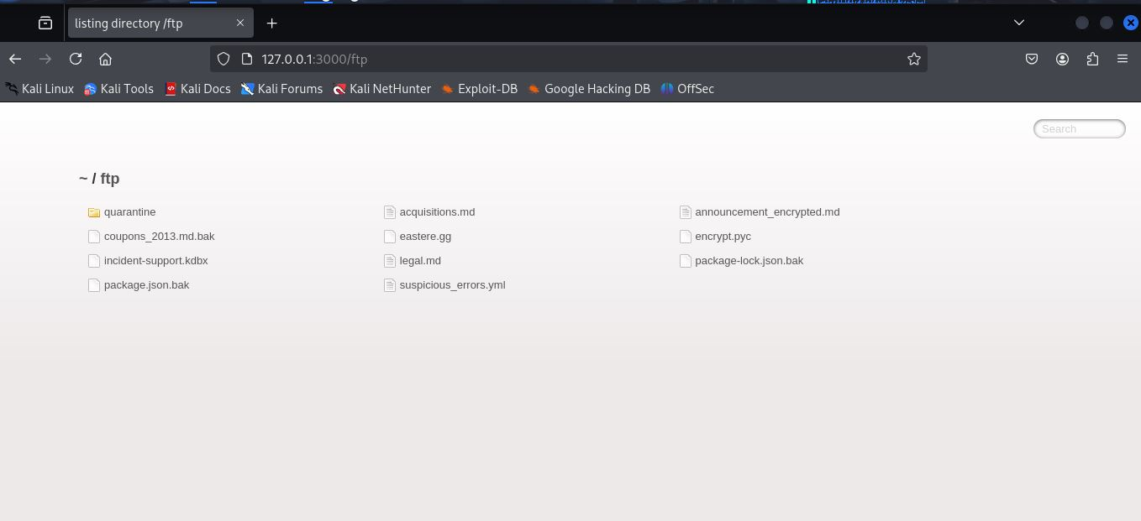

Evidence (robots.txt Analysis)
The robots.txt file of the target application was analyzed to identify disallowed or hidden paths. The file revealed restrictions related to FTP access and internal directories. The following paths and files were identified:
robots.txt Contents / Discovered Paths:
- Disallow: /ftp
- ~/ftp/
- ~/ftp/legal.egg
- Additional files and folders within the FTP directory
Screenshots highlighting the robots.txt contents and the discovered files and directories have been captured and attached as evidence.

Task 1 – Deliverables

1. Summary of Discovered Open Ports, Services, Pages, APIs, and Paths
During reconnaissance and application analysis, the following were identified:
- Open Ports & Services:
Multiple open ports were detected with active web services running on them.
- Pages & APIs:
Application endpoints such as /login and /whoami were identified through network traffic analysis.
- Application Files:
Client-side files including main.js, application.config, and multiple CSS files were discovered.
- Discovered Paths (robots.txt):
The robots.txt file revealed disallowed paths related to FTP access, including /ftp and internal directories containing files such as legal.egg.

2. Identified Potential Attack Vectors
Based on the findings, the following potential attack vectors were identified:
- Exposed open ports and services that may be targeted if not properly secured
- API endpoints that could be tested for authentication or authorization weaknesses
- Client-side JavaScript files that may expose application logic or sensitive information
- Disallowed paths found in robots.txt that could lead to sensitive directories or files

3. Screenshots with Explanations
Screenshots of the following have been captured and attached with brief explanations:
- Nmap scan results showing open ports and services
- Browser network traffic highlighting API endpoints
- JavaScript and configuration file analysis
- robots.txt contents and discovered paths

Task 2(part1)
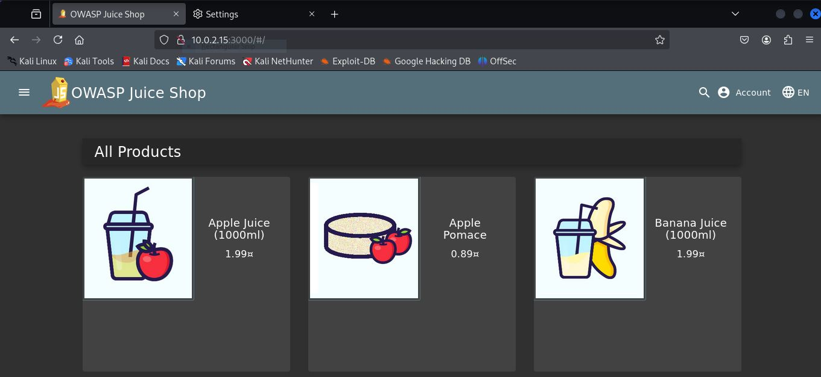
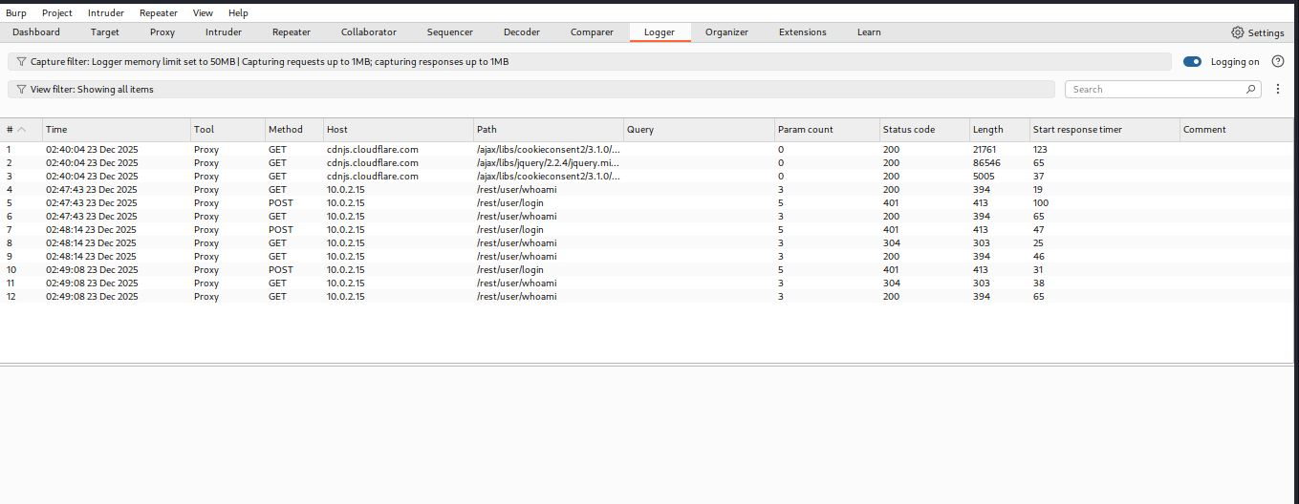
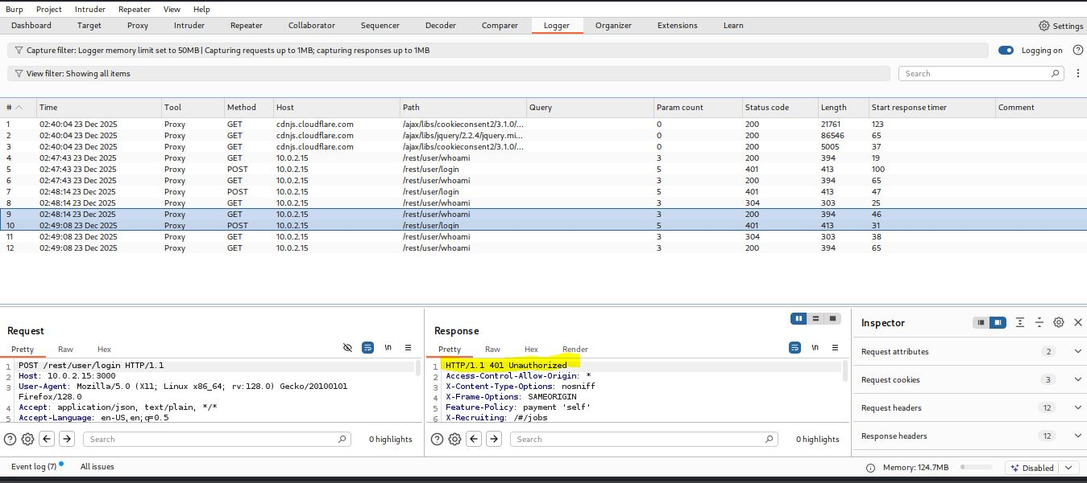
Task2(part2)
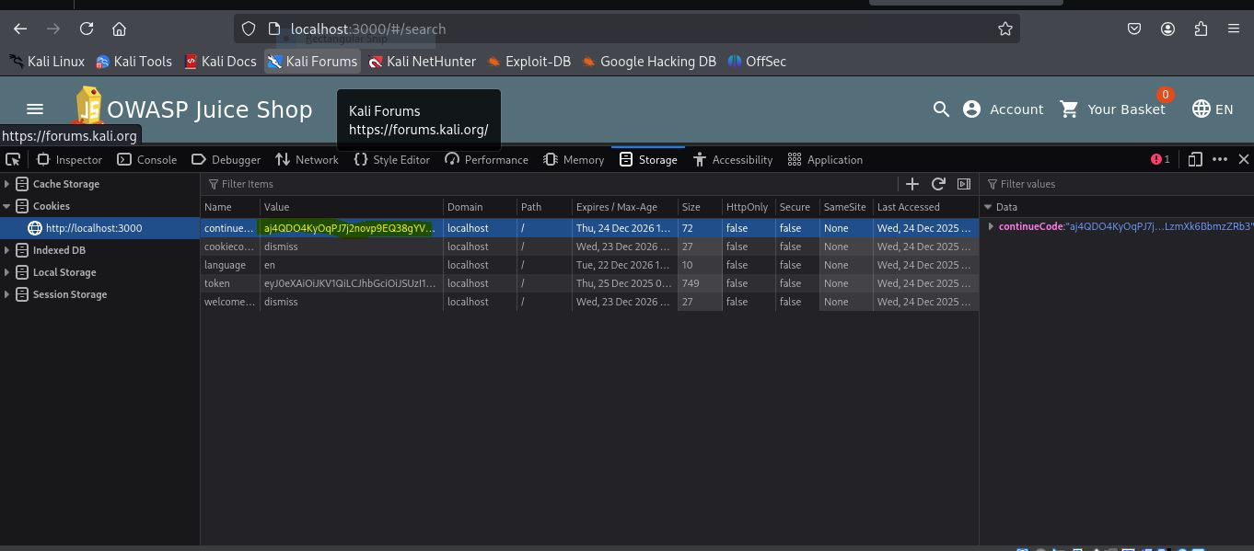

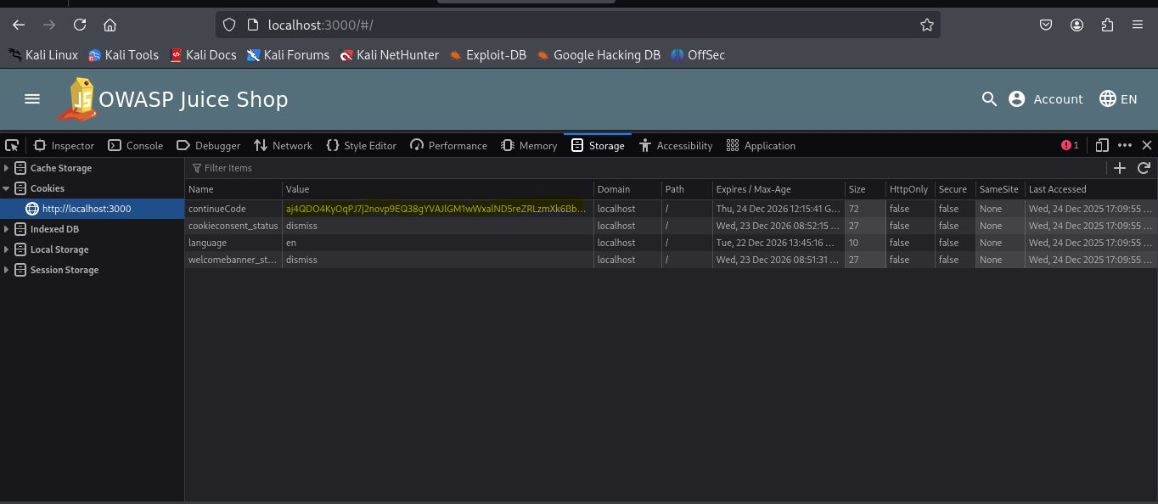
Task 2 - Deliverables
During authentication testing, login requests were intercepted using Burp Suite to analyze the parameters sent during the login process. The application was found to transmit authentication data such as username and password in a predictable manner, and weak or common passwords were accepted during testing. In addition, the server returned detailed error messages that differentiated between invalid usernames and incorrect passwords, which could assist an attacker in identifying valid user accounts. These observations indicate weak authentication controls that may allow unauthorized access.
Furthermore, session management testing revealed improper handling of session tokens. After successful login, session IDs were observed in browser cookies and remained valid across multiple browsers and sessions. In some cases, old session IDs were reusable even after the user logged out, indicating that sessions were not properly invalidated. It was also observed that session identifiers did not always change after login, increasing the risk of session fixation attacks. These weaknesses demonstrate that poor session handling could allow session hijacking and unauthorized access to user accounts.
Overall, the evidence collected confirms the presence of authentication and session management flaws. Screenshots of intercepted requests, weak authentication behavior, and session token reuse were captured and analyzed to support these findings. If exploited, these vulnerabilities could lead to account takeover and compromise of sensitive user data.

Task 3(part 1)
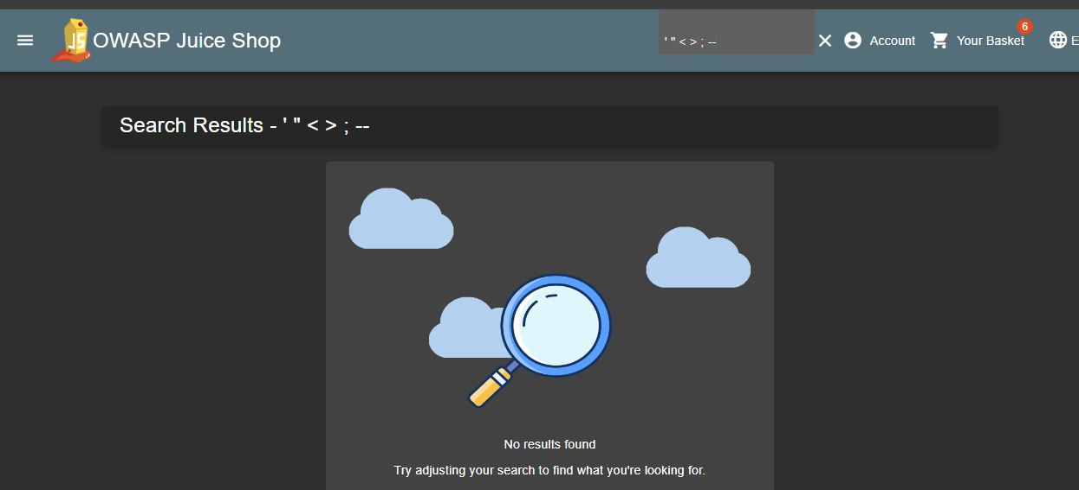
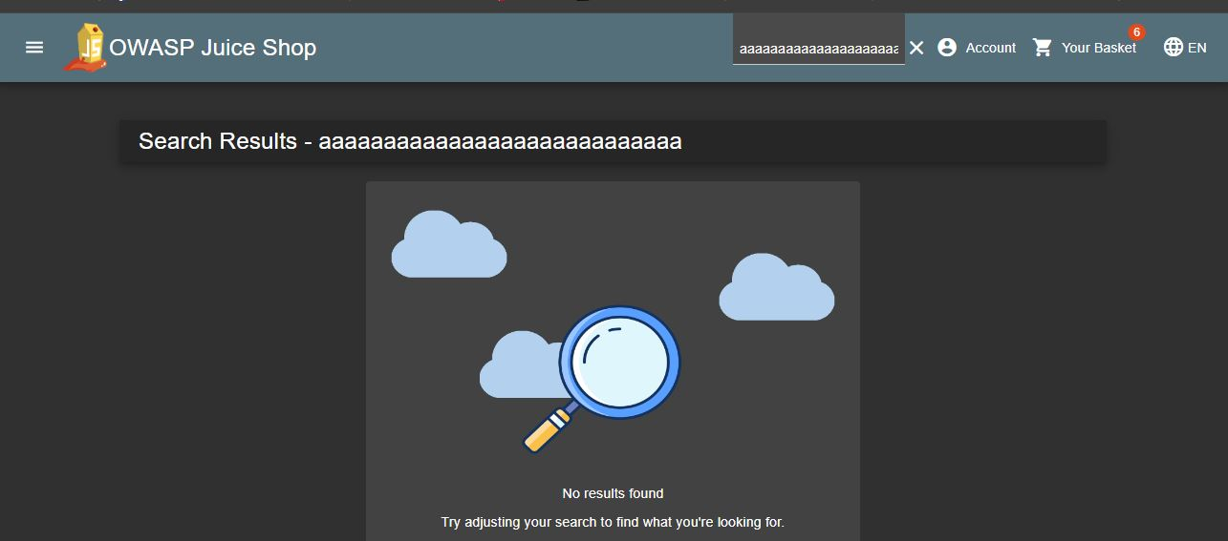
Task 3(part 2)
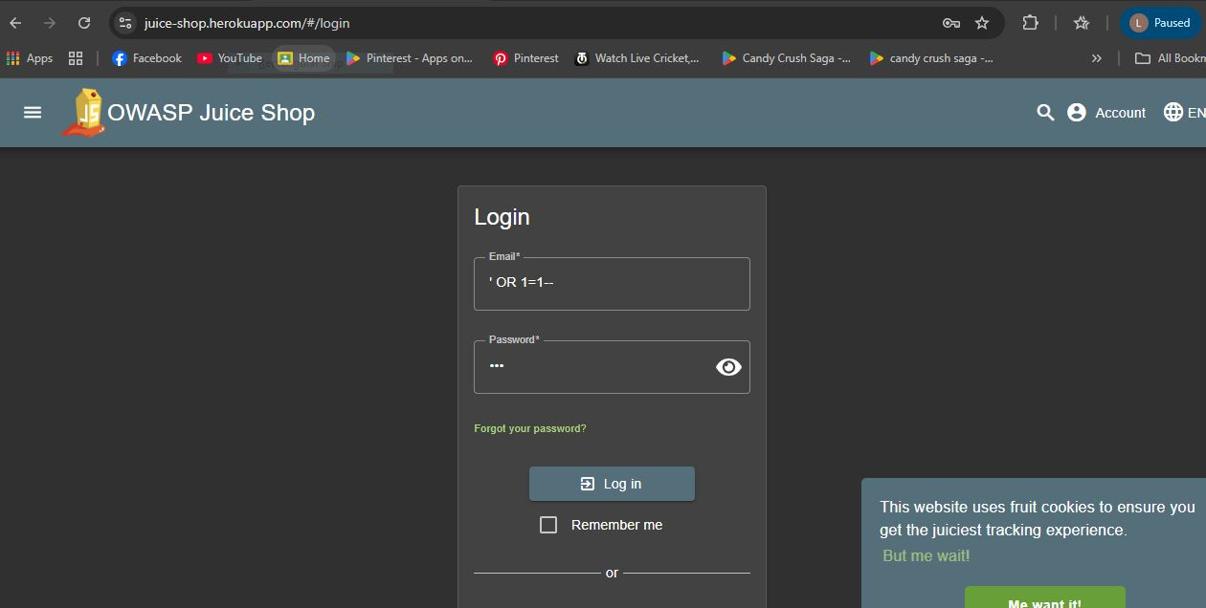
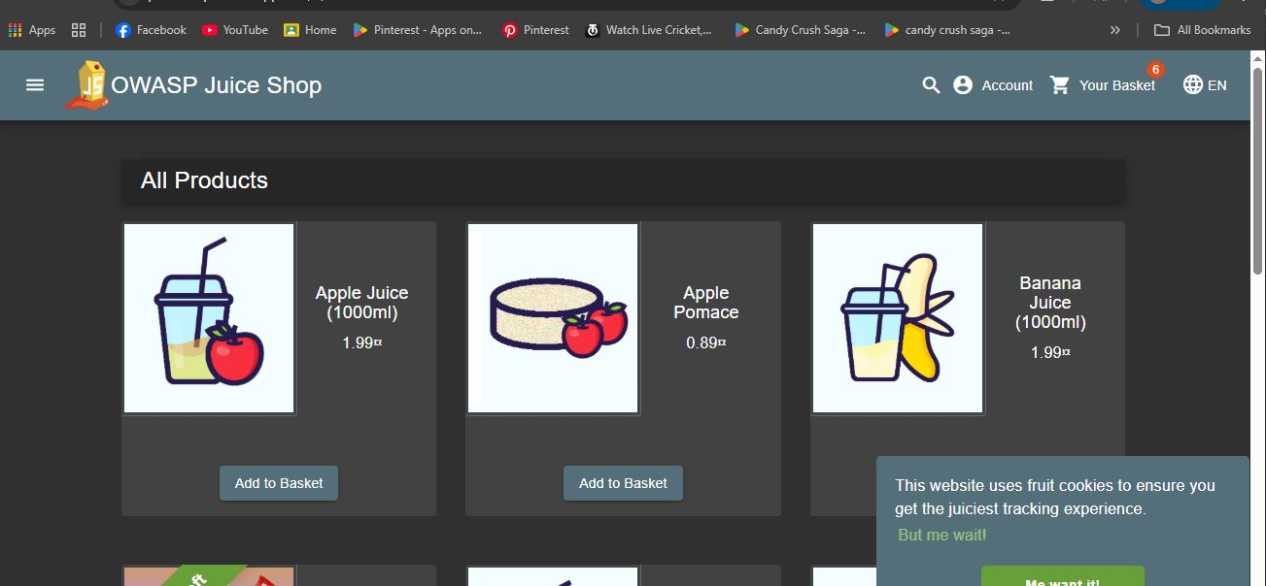
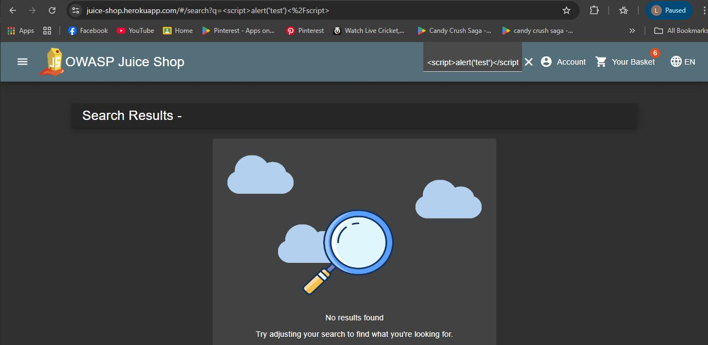
Task 3 – Deliverables
In this task, unsafe user input testing was performed on different input fields including login forms, search fields, and other user-controlled parameters. Various abnormal and unexpected input values were used, such as SQL injection and XSS payloads, to test input validation. The testing affected endpoints such as the login and search functionality where user input was directly processed by the application. The results showed that improper input validation can allow manipulation of application behavior, and in some cases could lead to database query manipulation or execution of scripts in the browser. This demonstrates that injection vulnerabilities can impact data integrity and user security if proper input validation and sanitization are not implemented. Screenshots of the payloads used and their impact were captured and attached as evidence.
Task 4(part 1)
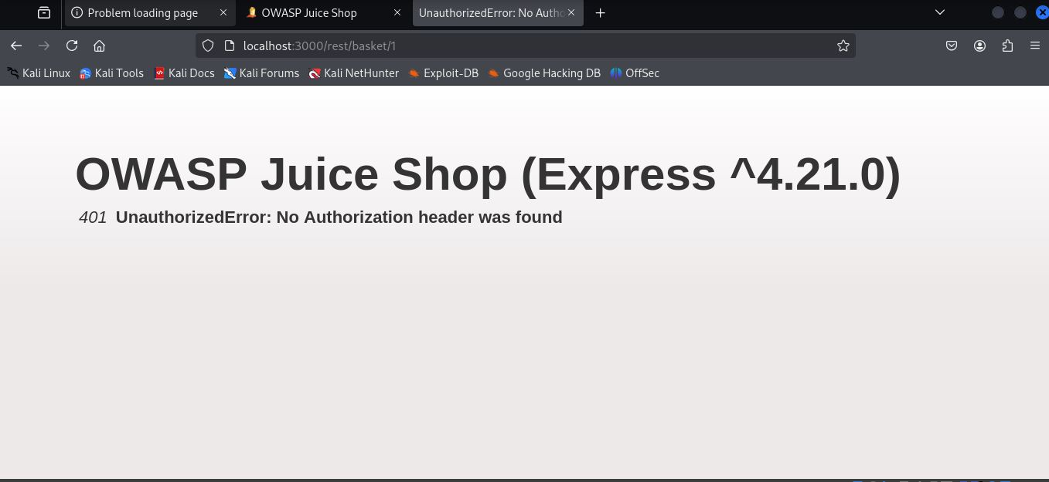
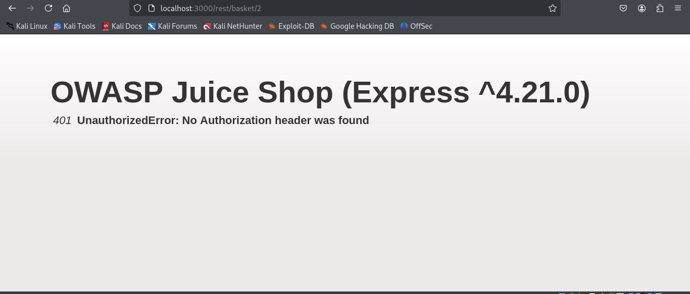
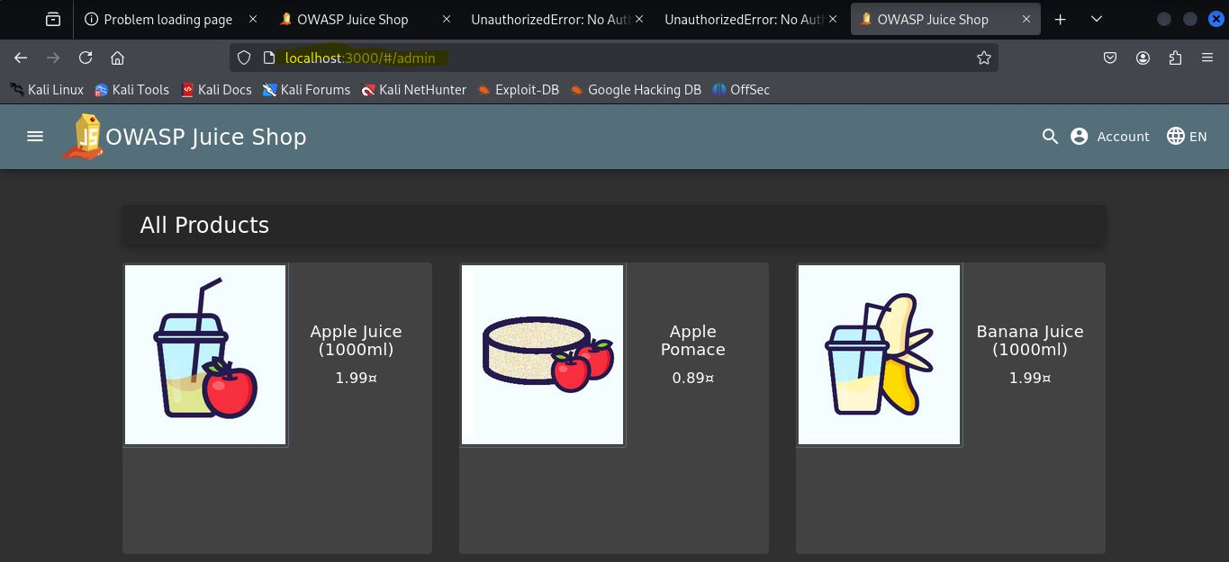
Task 4 (part2)
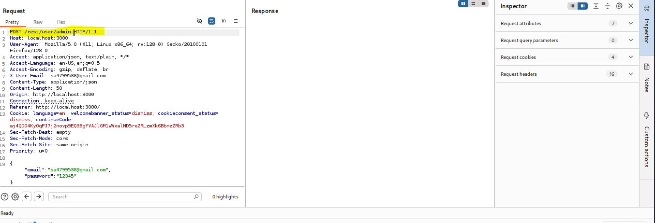
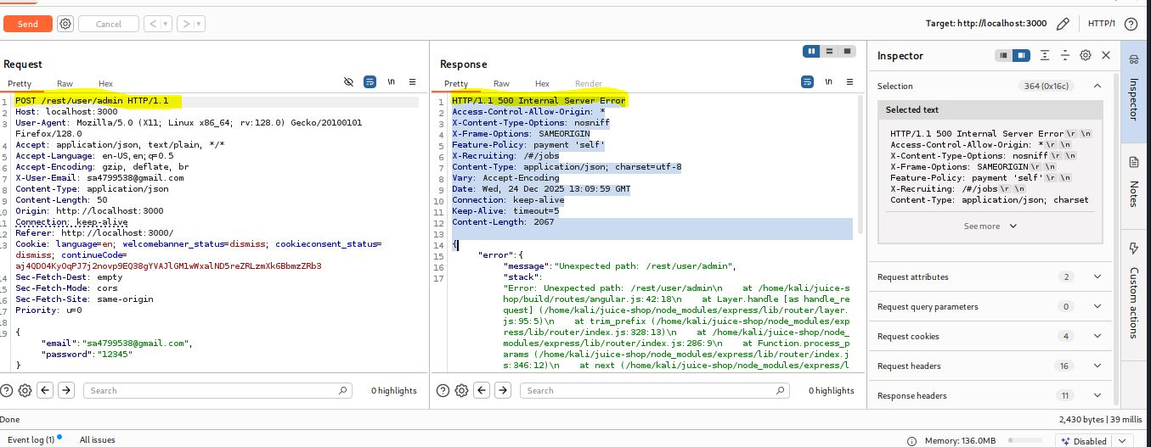
Task 4 - Deliverables
During Direct Object Access testing, restricted and administrative URLs were manually accessed by directly entering them into the browser and by replaying captured requests using Burp Suite without proper authorization. It was observed that certain protected pages could be accessed without sufficient permission checks on the server side. The server responded with successful status codes instead of denying access, indicating that authorization controls were either missing or improperly implemented. Screenshots of the tested URLs and server responses were captured as evidence of unauthorized access.
In Privilege Manipulation testing, authenticated user requests were intercepted and modified using Burp Suite. Parameters such as user IDs and role values were changed to attempt access to other users’ data and higher-privileged functions. In some cases, the server processed the modified requests without proper validation, allowing access beyond the user’s assigned privileges. This behavior demonstrates broken access control, where the application relies on client-side parameters rather than enforcing authorization checks on the server side.
Overall, the evidence collected confirms the presence of access control failures within the application. By directly accessing object URLs and manipulating privilege-related parameters, authorization restrictions were bypassed, allowing unauthorized actions and data exposure. These vulnerabilities pose a serious security risk and could lead to data breaches if exploited by an attacker.

Task 5 (part1)
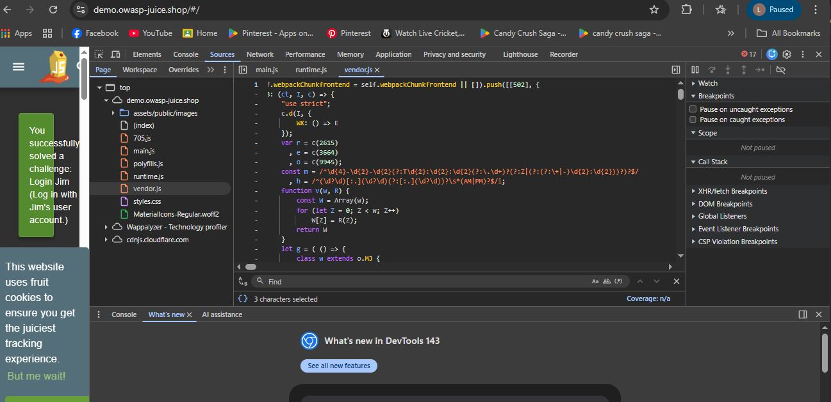
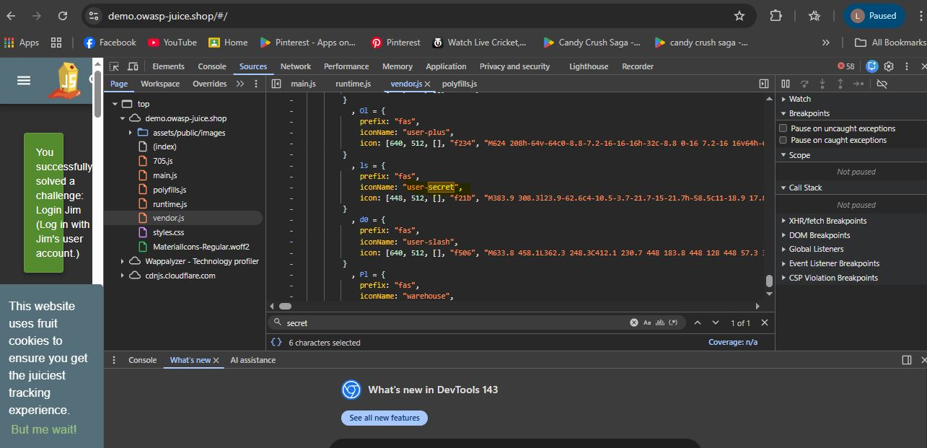
Task 5(part 2)
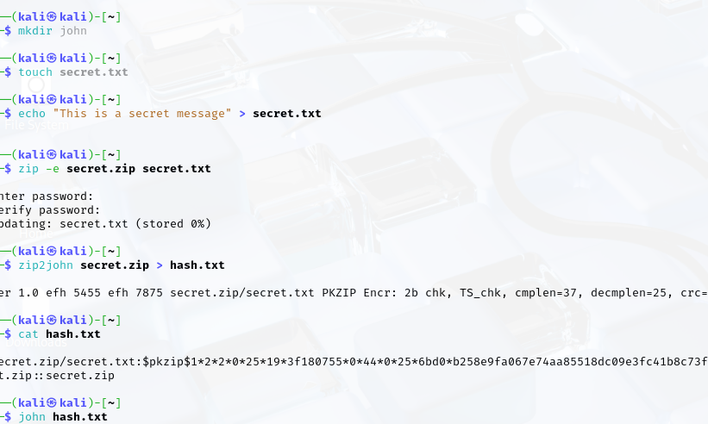
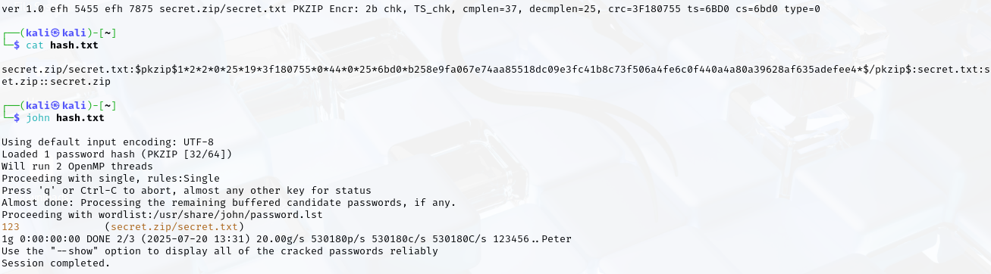
Task 5 -Deliverables
In this task, sensitive data exposure was analyzed by inspecting JavaScript files, API responses, and error messages using browser developer tools. The analysis focused on identifying exposed credentials, API keys, and internal system information within client-side resources and application responses. During the inspection, password hashes were identified in the application. The hash type was analyzed, and a controlled cracking attempt was performed using John the Ripper, which successfully revealed the password, demonstrating the weakness of the hashing mechanism. This confirms that exposed password hashes can lead to credential compromise if proper security controls are not applied. Additionally, some internal application information and client-side logic were observable through JavaScript files and network responses, which may help attackers understand the application’s data flow. Relevant screenshots of the inspection process, hash analysis, cracking results, and findings were captured and attached as evidence with brief explanations.
Special Objective: Unauthorized Account Takeover

Cenario Overview: Unauthorized Account Takeover via Session Fixation
In this scenario, an Unauthorized Account Takeover vulnerability was demonstrated by abusing improper session management. The application failed to regenerate the session identifier after user authentication. The same session token (continueCode) was observed both before login (unauthenticated state) and after login (authenticated state), indicating a session fixation flaw.

Step-by-Step Attack Path
First, the attacker accessed the application and obtained a valid session identifier without logging in. This session remained active and unchanged. The victim was then induced to log in using the same browser session. After successful authentication, the session identifier did not change. The attacker reused the previously obtained session token to gain unauthorized access to the victim’s authenticated account without knowing the victim’s credentials.

Impact and Evidence
This vulnerability allows a real attacker to fully hijack a victim’s account by reusing a fixed session identifier. As a result, the attacker can access sensitive user data and perform actions as the victim. Evidence of this attack includes identical session tokens before and after login, along with screenshots captured at each stage demonstrating the unchanged session ID and successful unauthorized access.

Recommendations
It is recommended that the application implements stronger authentication controls, including proper password policies and secure error handling. Session management should be improved by regenerating session identifiers after login and enforcing secure cookie attributes. All user inputs must be strictly validated and sanitized on the server side to prevent injection attacks. Access control checks should be enforced on the server for all sensitive functions and resources. Additionally, sensitive information should be removed from client-side files and API responses to reduce information exposure.

Conclusion
The Week 1 security assessment of the OWASP Juice Shop application identified several security weaknesses related to authentication, session management, input validation, access control, and data exposure. These issues demonstrate how insufficient security controls can be exploited to gain unauthorized access or perform restricted actions. The assessment provided practical insight into real-world penetration testing techniques and highlighted the importance of implementing secure design and defensive measures in web applications.

